April 9, 2021

To: The Chancellor’s Advisory Committee on Naming University Facilities and Units,

Over the past year, our community has witnessed powerful strides in Carolina’s shifting landscape. With the removal of the name Aycock during the summer of 2020, the Residence Hall Association and Carolina Housing saw a unique opportunity to represent the desires of those who reside in the hall. We believe residence halls are more than places where students live, but rather, centers for community, growth, and empathy. As you all likely realize, something as “simple” as a name fundamentally impacts the ways in which students view themselves and their places at Carolina. For years now, Residence Hall 1 has been an all-female hall, and many have slept with a name over their heads that did not represent the University’s values. We dream of a campus where every resident feels comfortable in the residence halls in which they reside and are proud to call them their home. With this goal in mind, the Residence Hall Association and Carolina Housing stand together in recommending your consideration of Residence Hall 1 to a name in recognition of an individual identifying as a woman.

While there are many women who are deserving of this honor, we believe that Karen Lynn Parker, Genevieve Lowry Cole, and Emily Steel would be excellent representatives of the values by which we live, and the graduates UNC-Chapel Hill produces. Each of these female leaders lived on campus, have made a tremendous positive impact on generations of Carolina students, and they are individuals who we hope our current and future residential students aspire to emulate. We encourage the Committee to not only consider current building names that may exist but the impact on students by seeing this representation around them. In addition to signaling to the residents in Residence Hall 1, who have been petitioning for this move, that their voices are heard, this also effectively communicates to our broader student population that Carolina values their lives, their experiences, and their passions. Although many have a vested interest in the renaming of buildings, we hope that you will value our recommendations as those who advocate directly on behalf of the on-campus population.

For the Residents,

Residence Hall Association, 2020-21 Executive Board

Carolina Housing
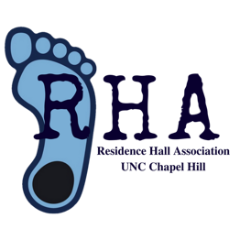
For more information on each of the female leaders referenced above, please see the following:

Karen Lynn Parker: https://exhibits.lib.unc.edu/exhibits/show/protest/biographies/karen-parker

Genevieve Lowry Cole: https://www.dailytarheel.com/article/2019/03/genevieve-lowry-cole-0318

Emily Steel: http://hussman.unc.edu/news/alumna-emily-steel-’06-wins-2018-pulitzer-prize-public-service

